**Creating Project in Jira**

1. **Creating Project in Scrum**

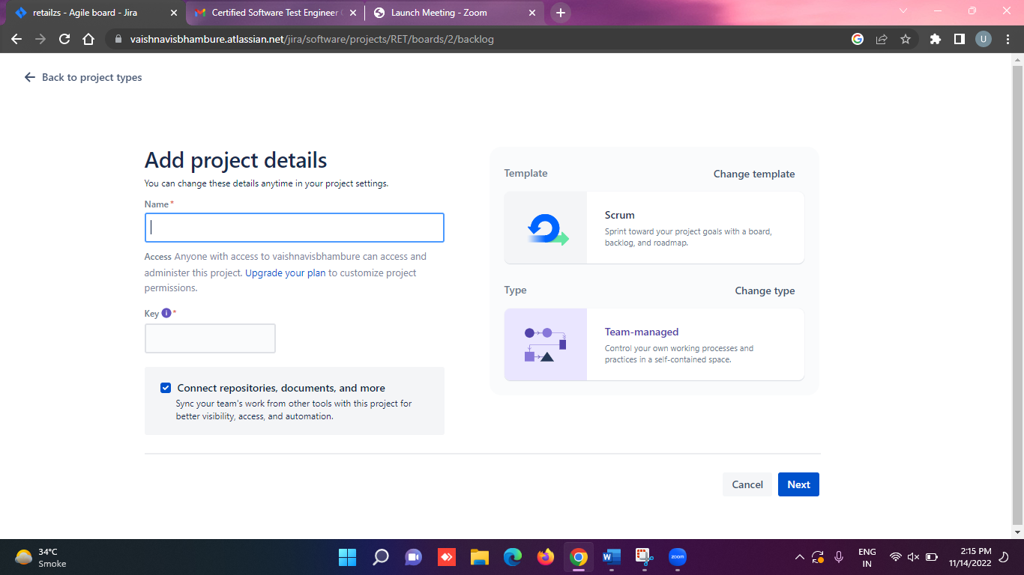

**Name:Reatils**

**Key:RET**

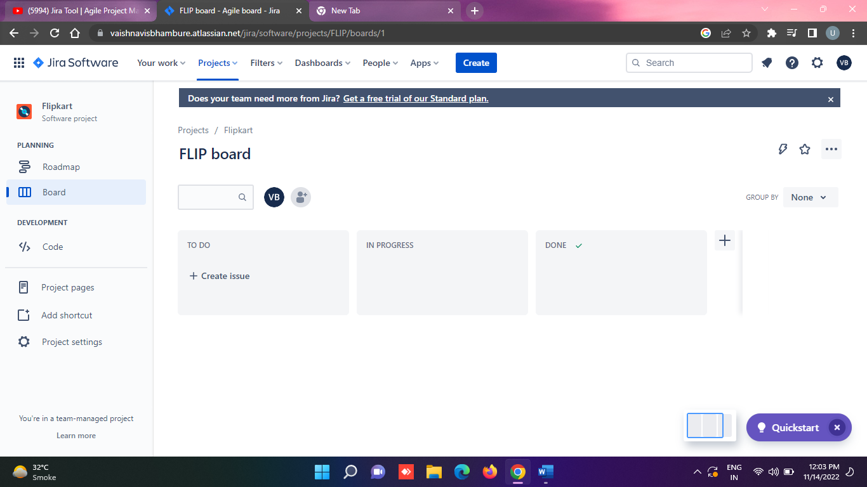

1. **Adding team members**

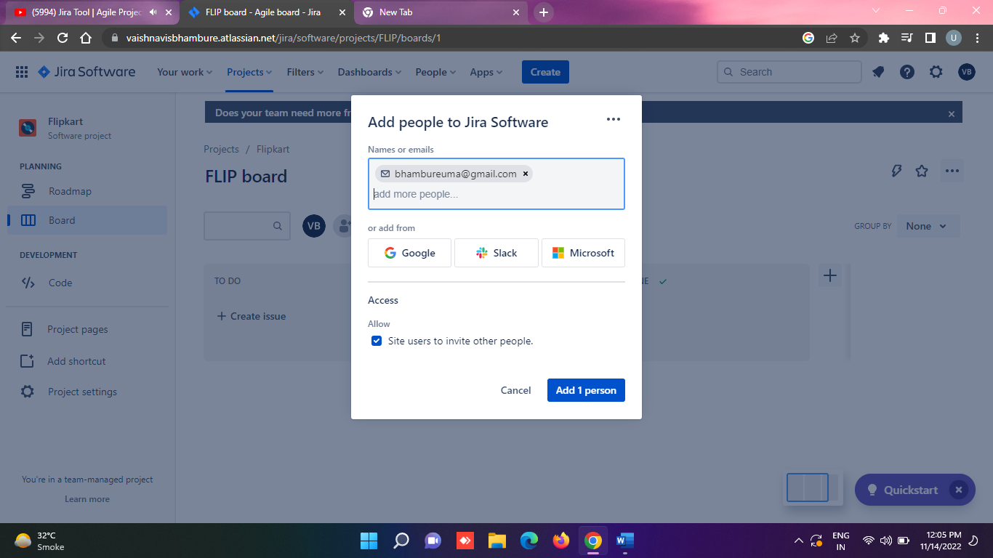

1. **To add Multiple user**

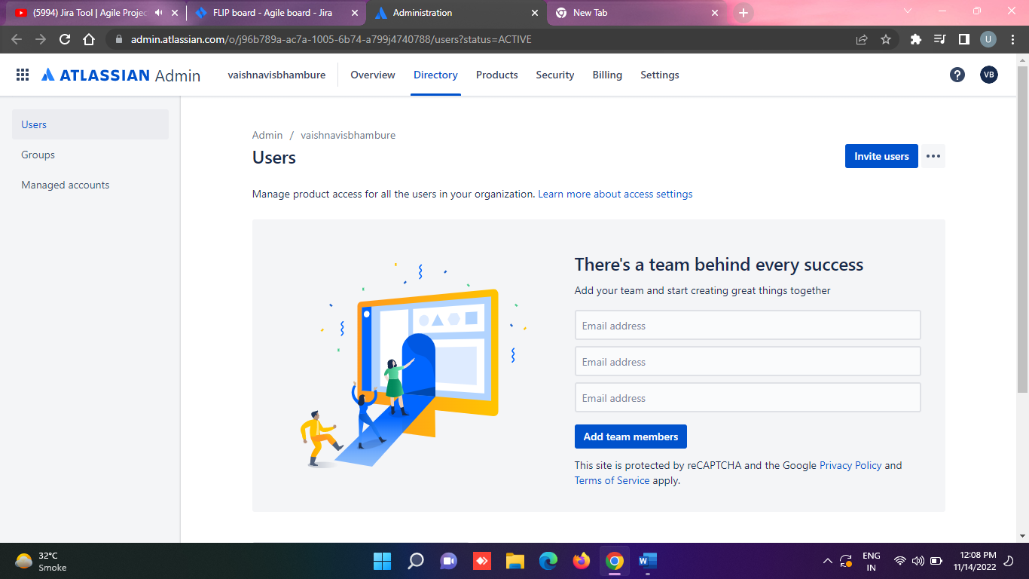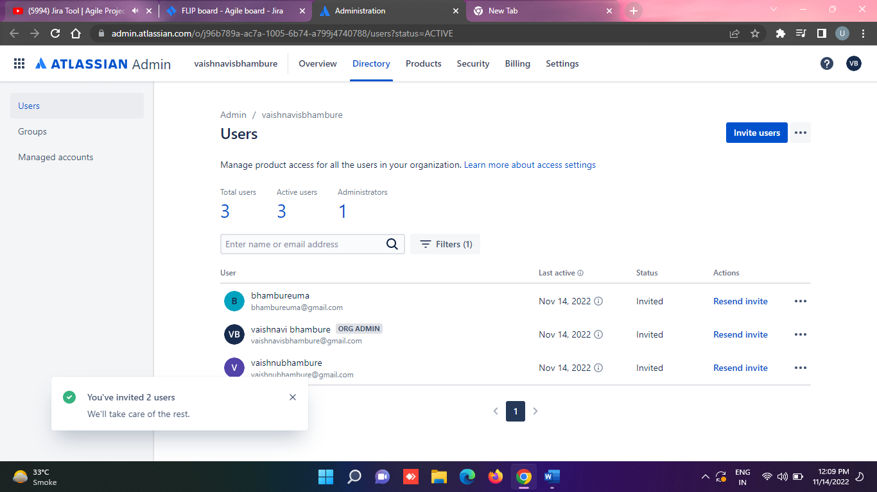

1. **Create Epic**

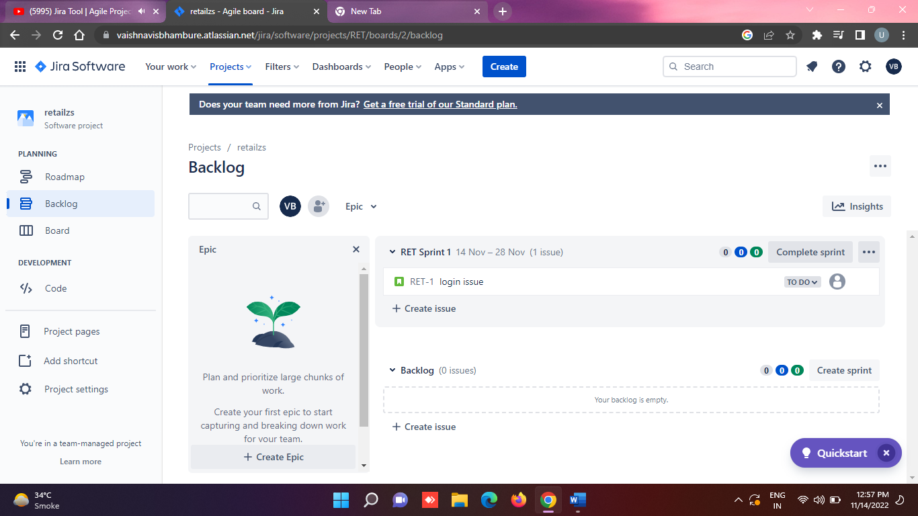

**5.Create Story -> Click on create**

**Select Project**

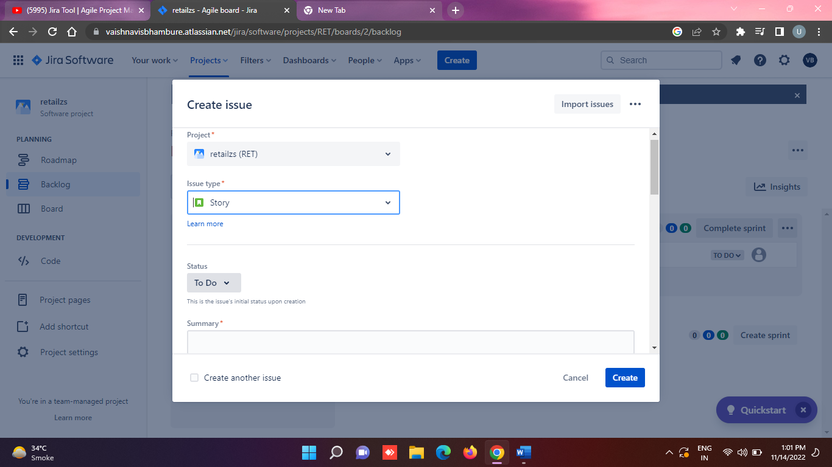

**6.Adding commect on created story ie**



